# Third-Person Camera Control in Unity using C#

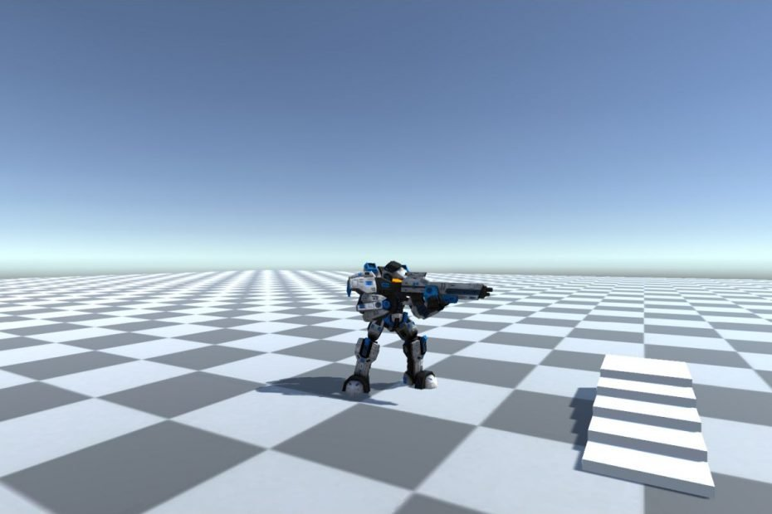

**Solutions to Programming Assignments**

Shamim Akhtar

### Programming Assignment 1 - Implement Player Movement

In this programming assignment, we will implement the **PlayerMovement** script for our Player.

Double click and open the **PlayerMovement.cs** file.

Add the following variables.

[HideInInspector]

public CharacterController mCharacterController;

public Animator mAnimator;

public float mWalkSpeed = 1.0f;

public float mRotationSpeed = 50.0f;

In the Start method, we cache the CharacterController component in the mCharacterController variable.

void Start()

{

mCharacterController = GetComponent<CharacterController>();

}

Implement the Update method to handle inputs and apply the movement to the Player.

void Update()

{

float hInput = Input.GetAxis("Horizontal");

float vInput = Input.GetAxis("Vertical");

float speed = mWalkSpeed;

if (Input.GetKey(KeyCode.LeftShift))

{

speed = mWalkSpeed * 2.0f;

}

if (mAnimator == null) return;

transform.Rotate(0.0f, hInput * mRotationSpeed * Time.deltaTime, 0.0f);

Vector3 forward =

transform.TransformDirection(Vector3.forward).normalized;

forward.y = 0.0f;

mCharacterController.Move(forward * vInput * speed * Time.deltaTime);

mAnimator.SetFloat("PosX", 0);

mAnimator.SetFloat("PosZ", vInput * speed / 2.0f * mWalkSpeed);

}

**Discuss in class how you can further refactor this code. Your tutor will guide you on refactoring.**